

**ECE 4550: Digital Signal Processing**

**MATLAB Assignment #1**

**Authors: Michael Jordan Sallmen**

% Problem #1: given the two signals x1(t)=cos(20*pi*t) and x2(t)=cos(100*pi*t)

% Sample these two signals with a) Fs=40Hz and b) Fs=100Hz

%Problem #1 MATLAB Solution:

% part a) when Fs=40Hz the following MATLAB code will plot x1(n) and x2(n)

clear

clc

Fs1=40;

i=1;

for n=0:1:60

t1 = n/Fs1;

t2 = n/Fs1;

t11(i) = t1;

t22(i) = t2;

x1 = cosd(20*pi*t1);

x11(i) = x1;

x2 = cosd(100*pi*t2);

x22(i) = x2;

i=i+1;

end

figure

subplot(2,1,1)

stem(x11)

title('x1(n) = cos(0.5\pin)')

xlabel('n')

ylabel('x1')

subplot(2,1,2)

stem(x22)

title('x1(n) = cos(0.2\pin)')

xlabel('n')

ylabel('x2')

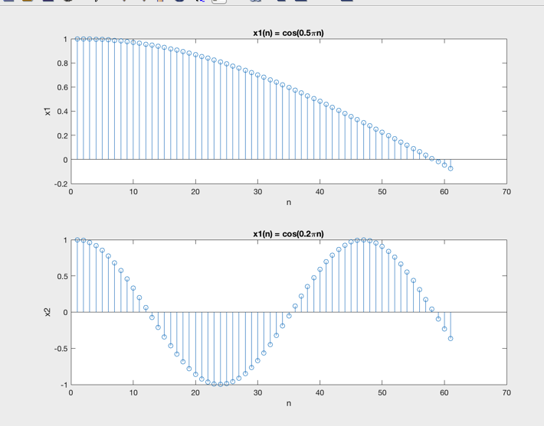

% part b) when Fs=100Hz the following MATLAB code will plot x1(n) and x2(n)

clear

clc

Fs2=100;

i=1;

for n=0:1:60

t1 = n/Fs2;

t2 = n/Fs2;

t11(i) = t1;

t22(i) = t2;

x1 = cosd(20*pi*t1);

x11(i) = x1;

x2 = cosd(100*pi*t2);

x22(i) = x2;

i=i+1;

end

figure

subplot(2,1,1)

stem(x11)

title('x1(n) = cos(0.2\pin)')

xlabel('n')

ylabel('x1')

subplot(2,1,2)

stem(x22)

title('x1(n) = cos(\pin)')

xlabel('n')

ylabel('x2')

